1. ⚙️ Step 1: Install and Secure MySQL on Ubuntu
First, you need to get the MySQL server running on your Ubuntu machine.
- Update Package Lists: Open your terminal and refresh your package manager's lists.
sudo apt update
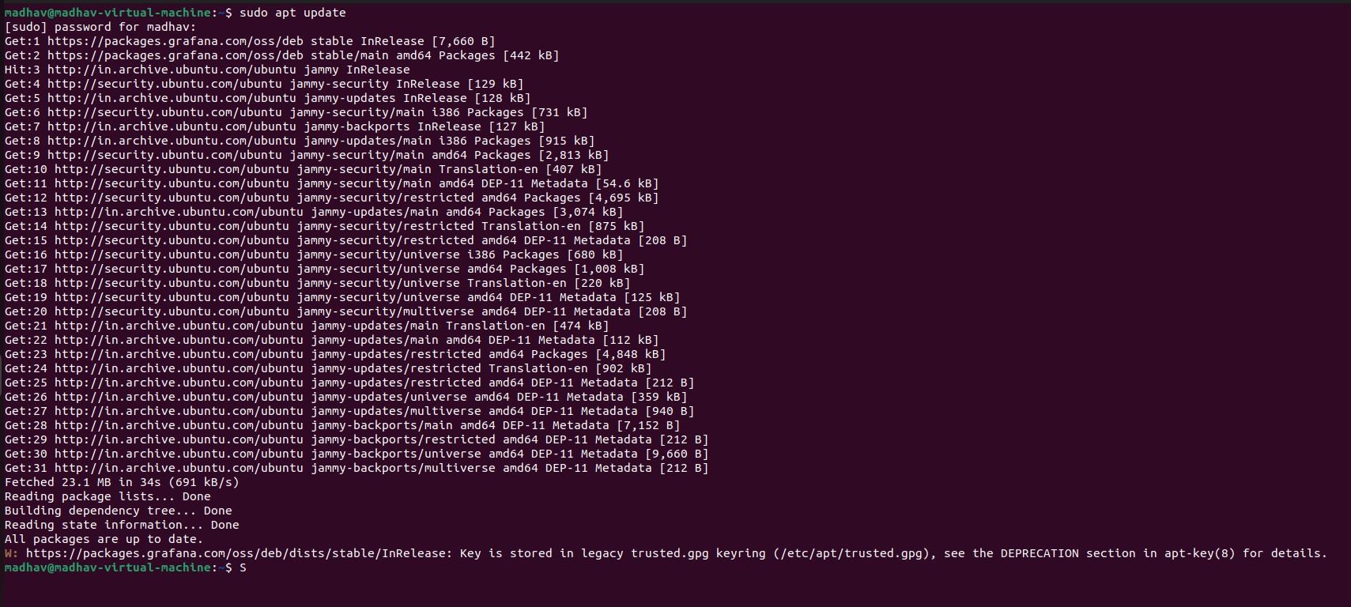
- Install MySQL Server: This command installs the server software.
sudo apt install mysql-server -y
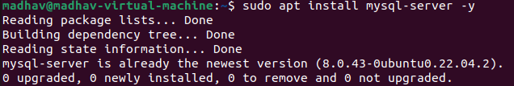
- Run the Secure Installation Script: This is a critical step. The script will guide you through setting a root password, removing anonymous users, and securing your server.
sudo mysql_secure_installation
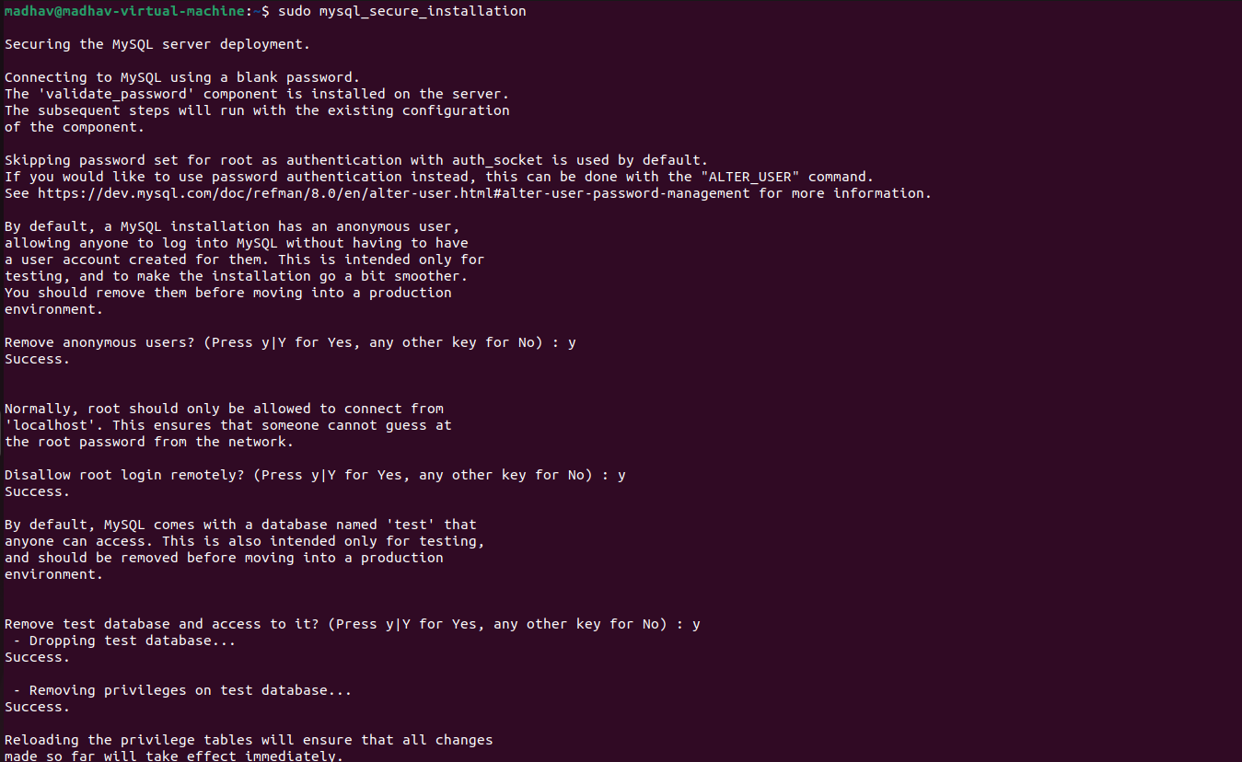

Note: For the "Validate Password Component," it's safe to say 'no' (n) if you want to use a simple password for this test. For a production server, you would want this enabled.
- Check Service Status: Verify that the MySQL server is active and running.
sudo systemctl status mysql
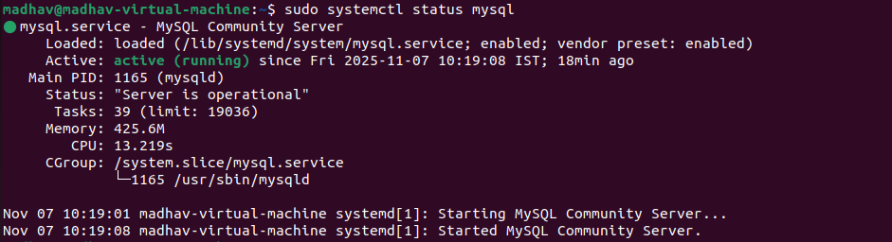

2. 🗃️ Step 2: Create Dummy Database, User, and Data
Now, let's log in to MySQL and create the database Grafana will connect to.
- Log in to MySQL as Root:
sudo mysql
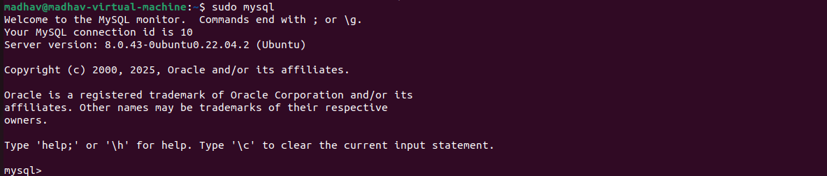
- Create a New Database: Let's call it grafana_dummy_db.
CREATE DATABASE grafana_dummy_db;

- Create a New User for Grafana: It's bad practice to use the root user. Let's create a dedicated, read-only user for Grafana.
  - Replace YourStrongPassword with a password of your choice.
  - '%' allows the user to connect from any IP address (which is useful if Grafana is on another server or in a Docker container). If Grafana is on the same machine, you can use 'localhost'.
CREATE USER 'grafana_user'@'%' IDENTIFIED BY 'aDYPU@12345';
- Grant Privileges: Give your new user SELECT (read-only) permission on the new database.
GRANT SELECT ON grafana_dummy_db.* TO 'grafana_user'@'%';
- Apply Changes:
FLUSH PRIVILEGES;
- Create a Table and Add Data: Now, let's create a sample table. Time-series data is best for Grafana.
-- Switch to your new database
USE grafana_dummy_db;
-- Create a table to store dummy server metrics
CREATE TABLE server_metrics (
time_stamp DATETIME NOT NULL,
server_name VARCHAR(50) NOT NULL,
cpu_usage DECIMAL(5, 2),
memory_usage_mb INT
);
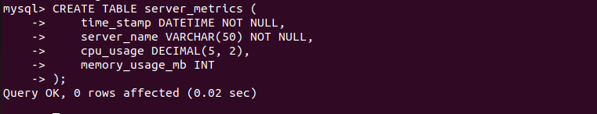

-- Insert some sample data
INSERT INTO server_metrics (time_stamp, server_name, cpu_usage, memory_usage_mb) VALUES
(NOW() - INTERVAL 4 HOUR, 'web-server-01', 15.5, 1024),
(NOW() - INTERVAL 4 HOUR, 'db-server-01', 25.2, 4096),
(NOW() - INTERVAL 3 HOUR, 'web-server-01', 18.1, 1150),
(NOW() - INTERVAL 3 HOUR, 'db-server-01', 30.0, 4120),
(NOW() - INTERVAL 2 HOUR, 'web-server-01', 12.0, 1000),
(NOW() - INTERVAL 2 HOUR, 'db-server-01', 22.7, 4100),
(NOW() - INTERVAL 1 HOUR, 'web-server-01', 14.2, 1080),
(NOW() - INTERVAL 1 HOUR, 'db-server-01', 28.5, 4150),
(NOW(), 'web-server-01', 20.0, 1200),
(NOW(), 'db-server-01', 35.1, 4200);
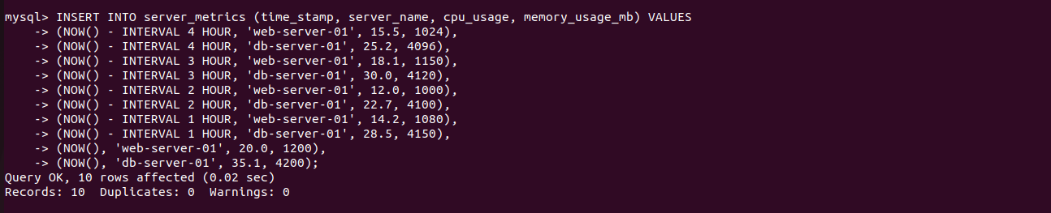
- Exit MySQL:
SQL
EXIT;


3. 🌐 Step 3: Configure MySQL and Grafana Connection
By default, MySQL only listens for connections from localhost. If your Grafana is on a different machine, you must allow remote connections.
- Edit MySQL Config File:
sudo nano /etc/mysql/mysql.conf.d/mysqld.cnf
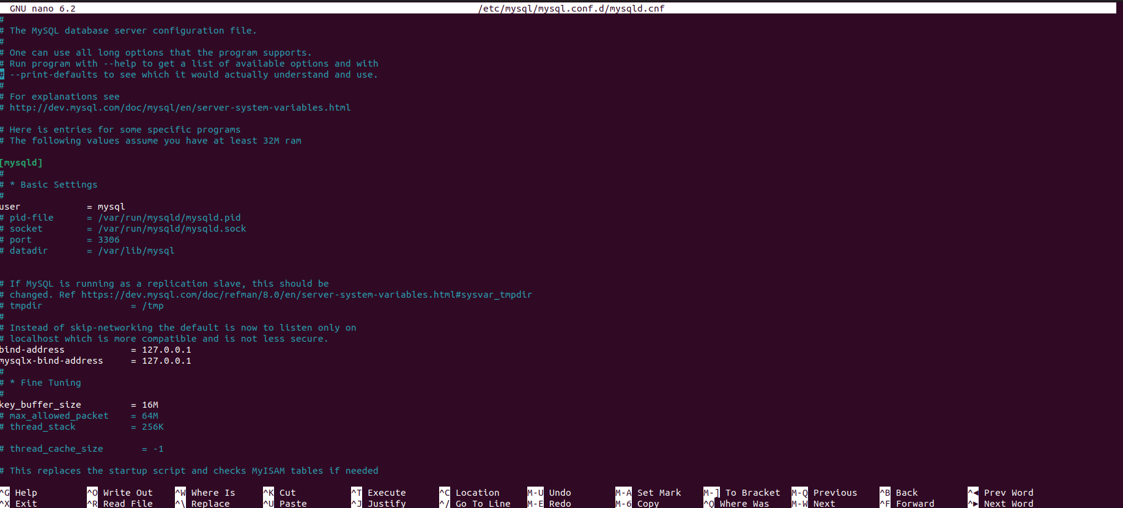
- Change Bind Address: Find the line that says bind-address = 127.0.0.1. Change it to allow all IPs:
Ini, TOML
bind-address = 0.0.0.0
Press Ctrl+O to save and Ctrl+X to exit.
- Restart MySQL:
sudo systemctl restart mysql
- (If using a firewall) Allow Port 3306: If you have ufw (Uncomplicated Firewall) enabled:
sudo ufw allow 3306/tcp
- Add Data Source in Grafana:
  - Log in to your Grafana web interface.
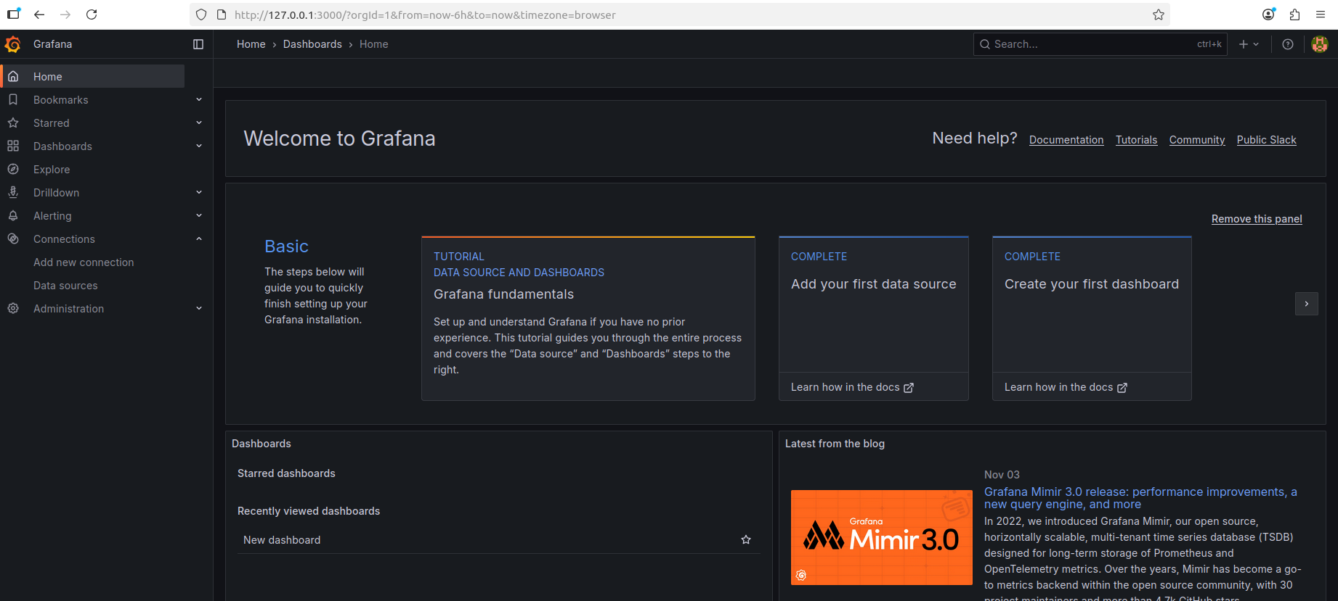
  - On the left menu, go to Connections (plug icon) -> Data sources.
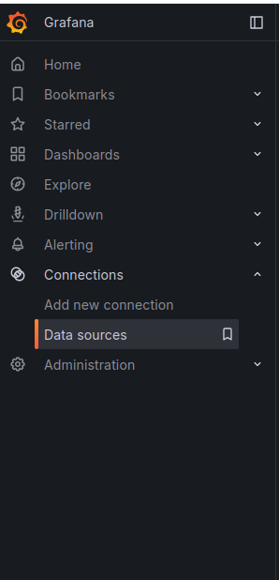
  - Click Add data source.
  - Search for and select MySQL.
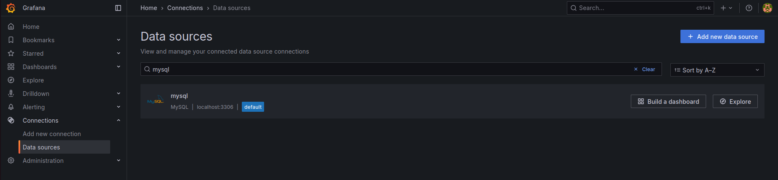
  - Fill in the connection details:
    - Host: Your-Ubuntu-Server-IP:3306
    - Database: grafana_dummy_db
    - User: grafana_user
    - Password: YourStrongPassword
    - TLS/SSL Mode: disable (for this test)
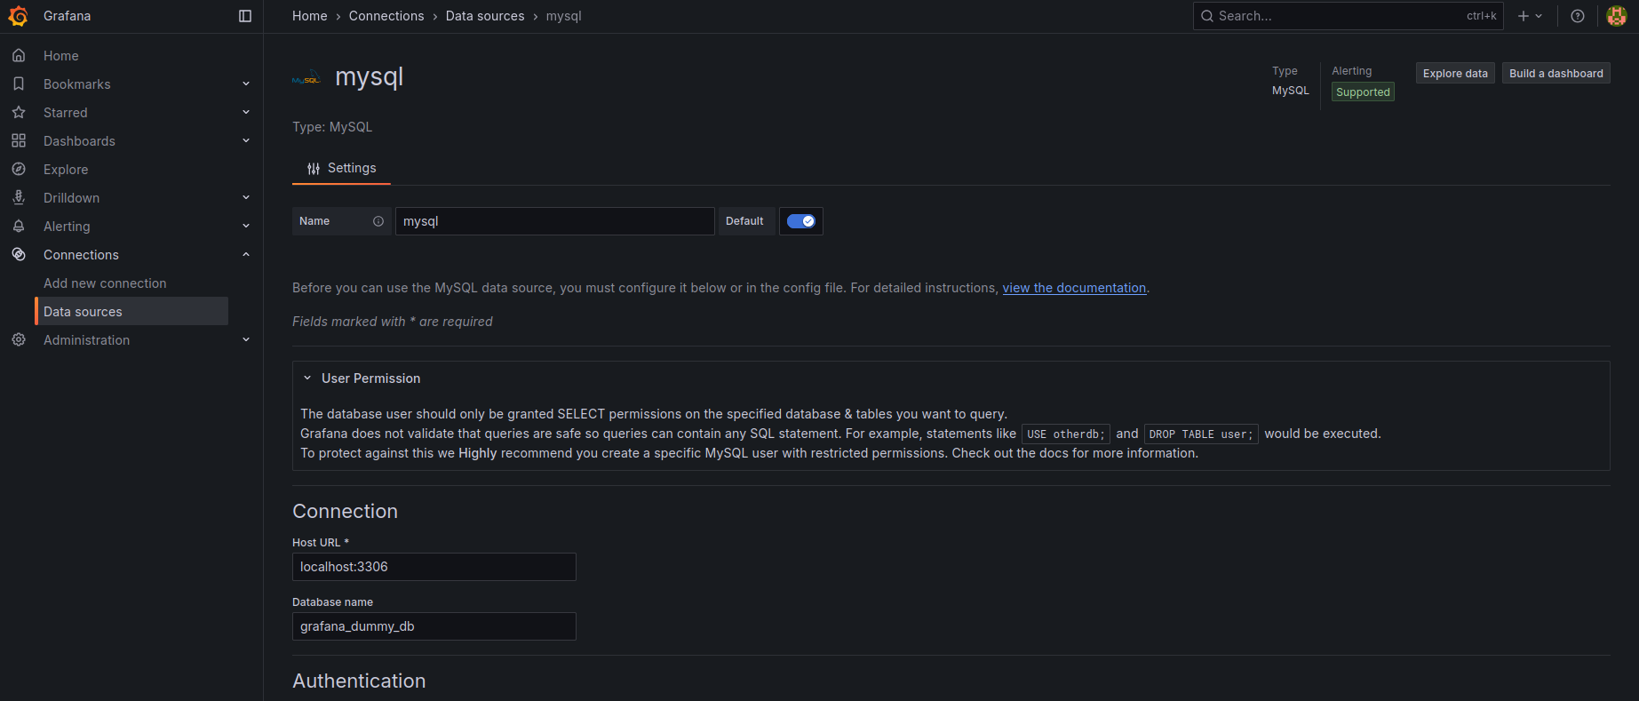
  - Click Save & test. You should see a green "Database connection OK" message.
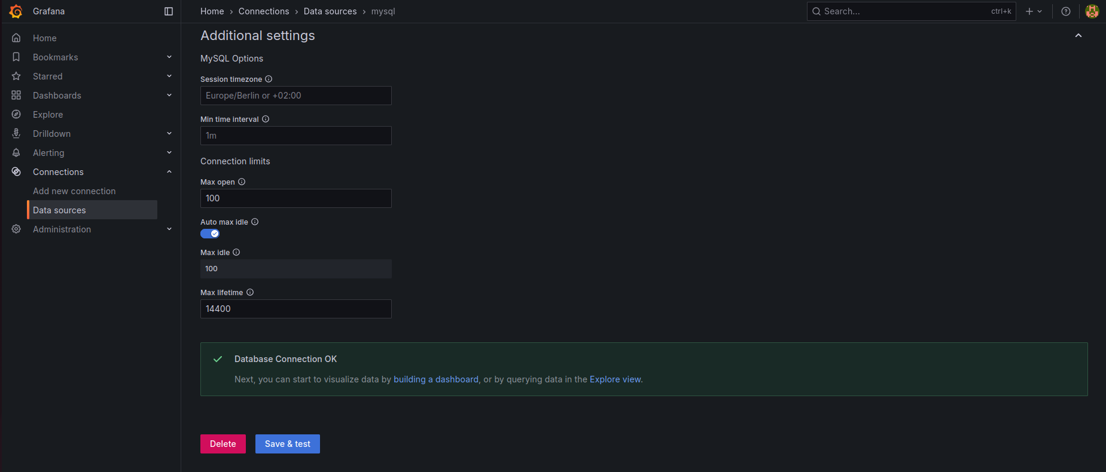

4. 📊 Step 4: Create a Grafana Dashboard
Let's use the dummy data to build a graph.
- Create a New Dashboard:
  - On the left menu, click the Dashboards (four squares) icon.
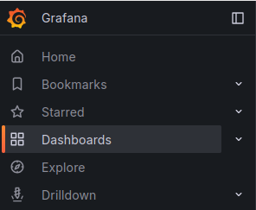
  - Click New -> New Dashboard.
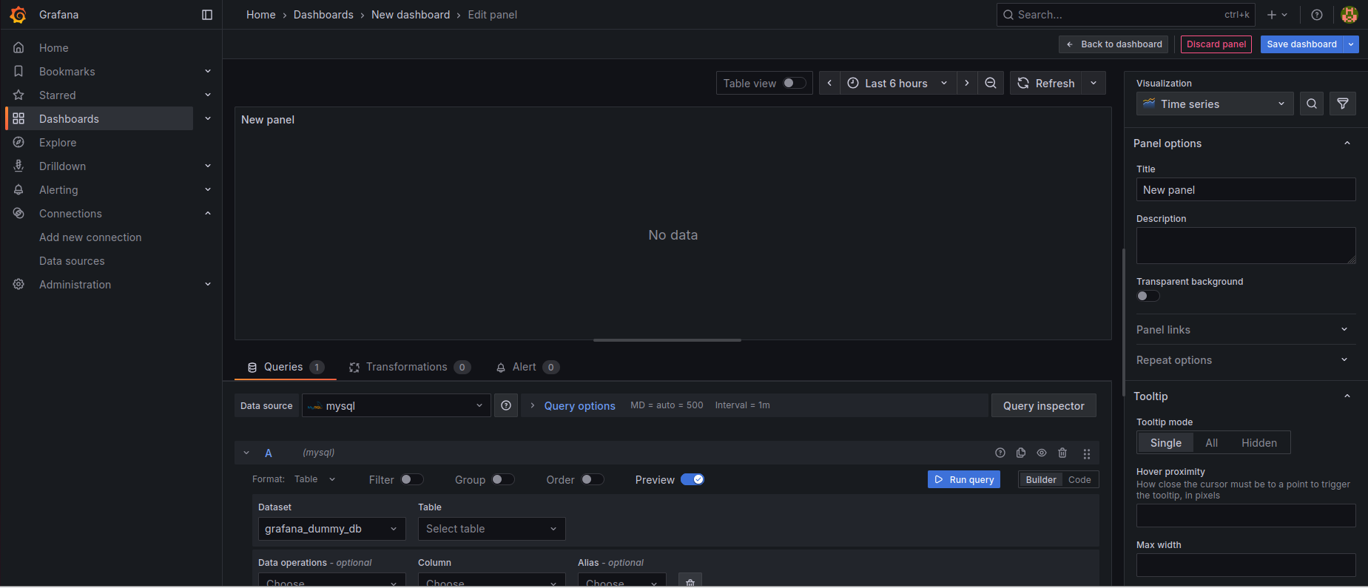
  - Click Add visualization.
- Select Data Source: At the top, select your MySQL data source.
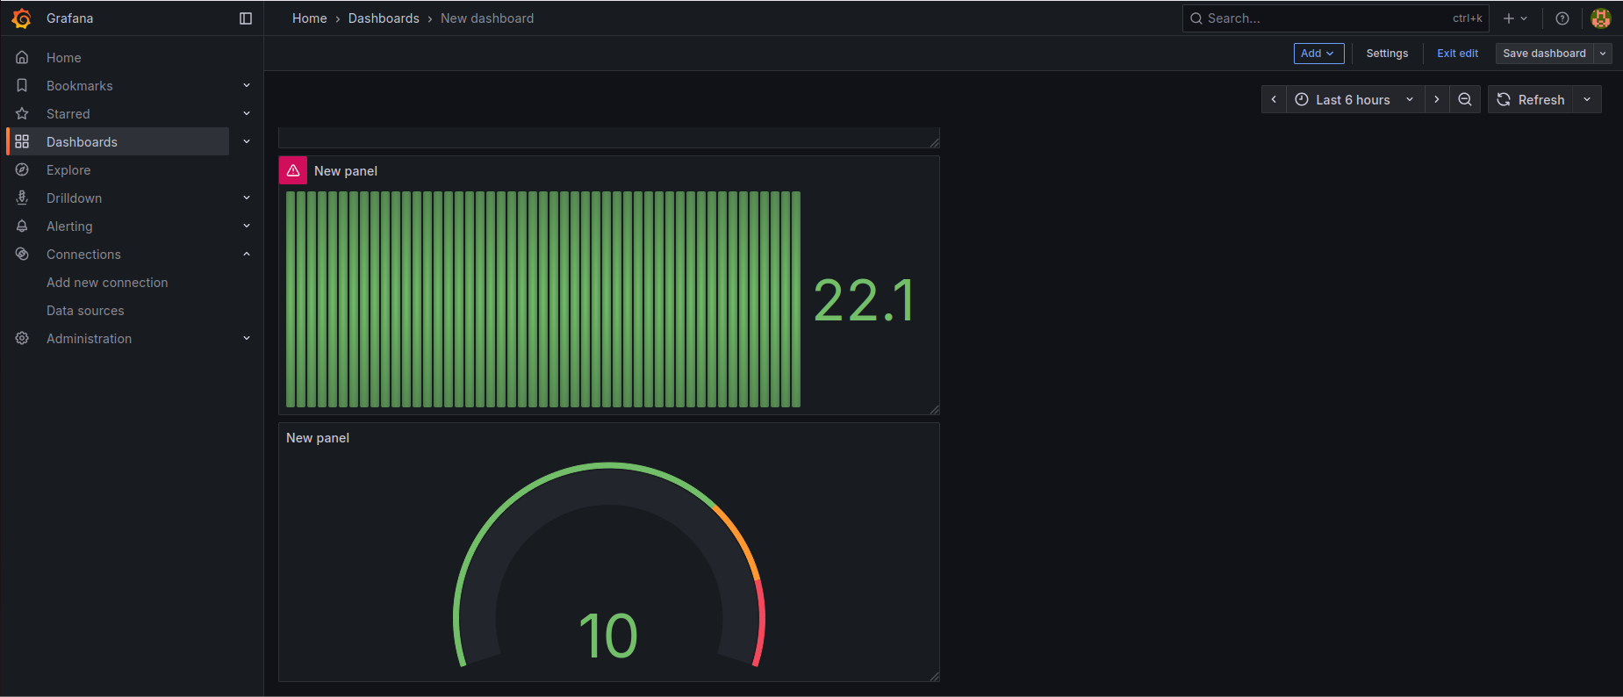
- Enter the Query:
  - At the bottom, click the </> Code button to open the query editor.
  - Delete any placeholder text and paste in the following SQL query:
SQL
SELECT
time_stamp AS "time", -- Grafana needs a column named 'time'
server_name AS "metric", -- This will name the lines (e.g., 'web-server-01')
cpu_usage -- This is the value to plot
FROM
server_metrics
WHERE
$__timeFilter(time_stamp) -- This macro lets Grafana's time picker control the query
ORDER BY
time_stamp ASC;
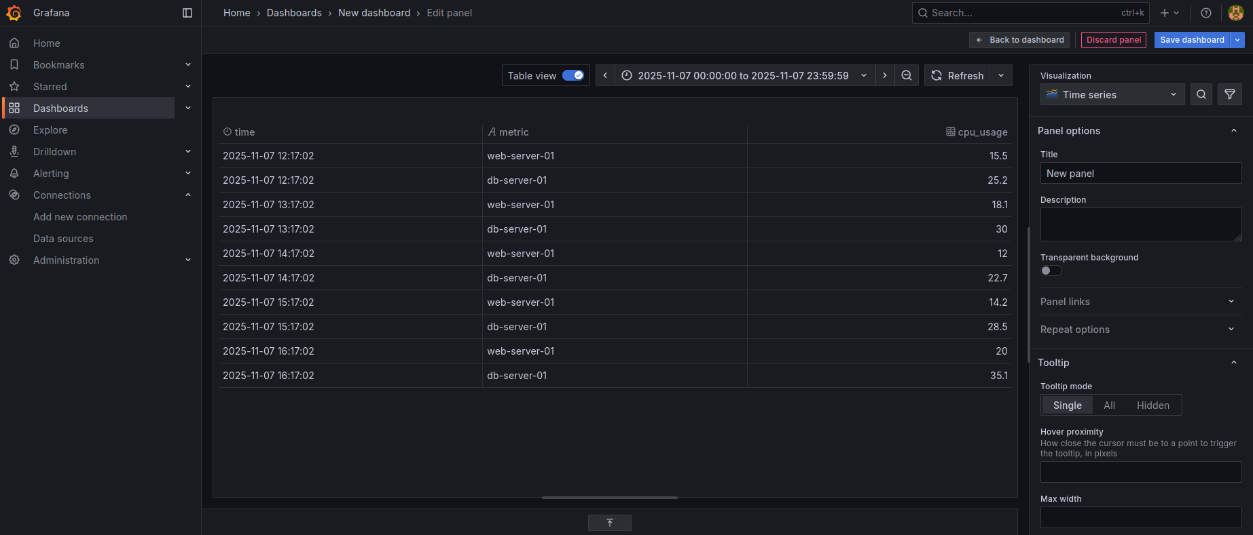
- Visualize!
  - If you see "No data," change the time range at the top right of the dashboard from "Last 6 hours" to "Last 6 hours" or "Last 2 days". This will ensure your sample data is visible.
  - On the right-hand panel, you can change the visualization type. It should default to Time series, which is perfect.
  - You should now see two lines on your graph: one for web-server-01 and one for db-server-01, plotting their CPU usage over time.
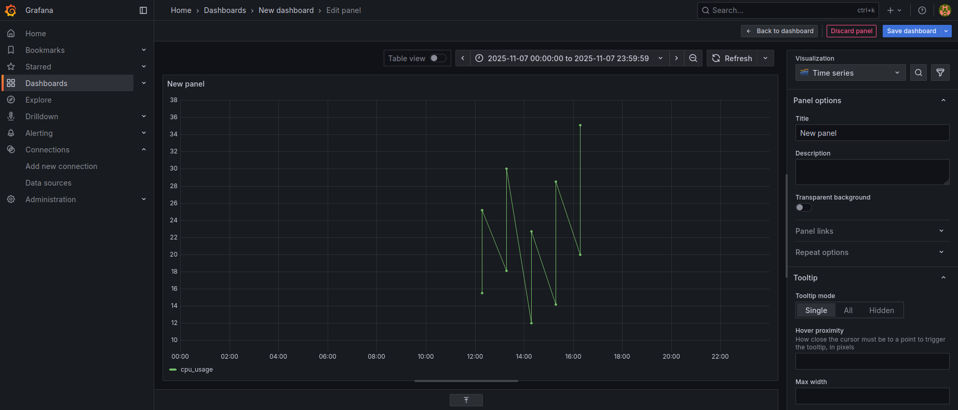
- Save Your Dashboard:
  - Click Apply in the top right of the panel.
  - Click the Save (disk) icon at the top of the dashboard.
  - Give your dashboard a name (e.g., "MySQL Server Metrics") and click Save.
You now have a complete, working Grafana dashboard visualizing data from your MySQL server!

